CHEMISTRY 12 ATCHE Task 9

2023 Organic Chemistry TEST ANSWER SHEET

Recommended time: 45 minutes
Total marks

/ 46
Name: _____________________________________________________

Teacher: _____________________________________________________

This test has three sections.

Section 1: Multiple choice style consisting of six (6) questions.
Each question is worth 2 marks.
Write your answers in the multiple choice answer sheet provided.

Section 2: Short answer questions consisting of four (4) questions worth 18 marks.
The marks allocated to each question are shown next to each question.
Write all answers in the spaces provided.

Section 3: One (1) extended response question worth 15 marks.
The marks allocated to each part are shown next to each part.
Write all answers in the spaces provided.
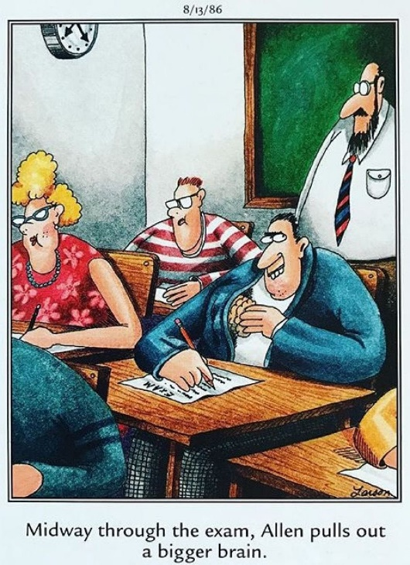

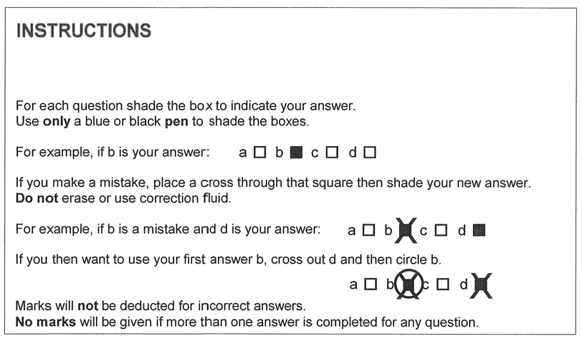

1. | a o | b o | c o | d o
2. | a o | b o | c o | d o
3. | a o | b o | c o | d o
4. | a o | b o | c o | d o
5. | a o | b o | c o | d o
6. | a o | b o | c o | d o

/12

SECTION ONE: MULTIPLE CHOICE QUESTIONS (12 marks)
- Consider the molecule aspartame, shown below.
Which of the following functional groups is not present in aspartame?
- amine
- alcohol
- amide
- ester

- Which of the following molecules could have a geometric isomer?
- 1,1-chloro-prop-1-ene
- 1,2-dichloroprop-1-ene
- but-1-ene
- 2-chlorobut-1-ene

- The following shows the reaction between dodecyl sulphate and sodium hydroxide:
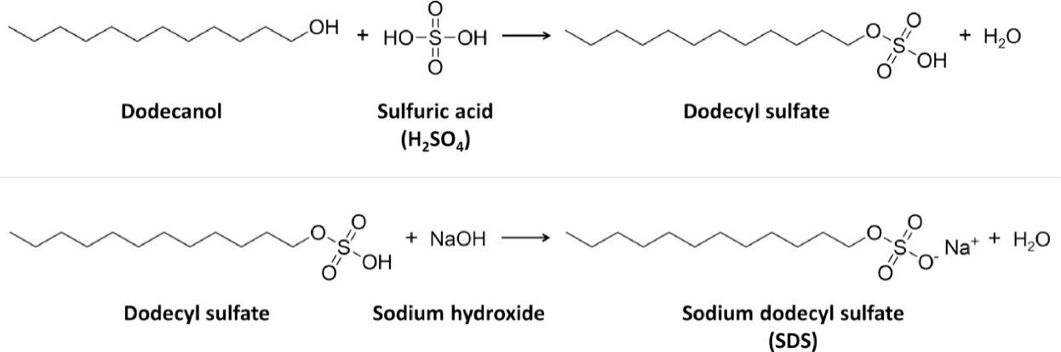
Which of the following options best describes the reaction taking place as well as the class of the ionic product?

Reaction Type Chemical Class
- Saponification Detergent
- Saponification Soap
- Neutralisation Detergent
- Neutralisation Soap

- The following graph shows the boiling point of four different hydrocarbons – propanone, propan-1-ol, propanoic acid, and propanal.

Which compound is most likely to be propanoic acid?

- A
- B
- C
- D

- Which of the following substances would you expect to have the highest boiling point?
- ethanoic acid
- methanoic acid
- ethanal
- ethanol

- Consider a micelle formed from soap particles, as shown below. The two (2) distinct regions of the soap particle are labelled as X and Y.
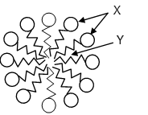
Which of the following correctly identifies X and Y?
X Y
- Polar head Non-polar tail
- Non-polar head Polar tail
- Polar tail Non-polar head
- Non-polar tail Polar head

END OF SECTION ONE
SECTION TWO: SHORT ANSWER QUESTIONS (19 marks)

Question 7 (3 marks)
Complete the following table showing the structure and names of three organic compounds.

Structure | IUPAC Name
 | 2-methylpentan-3-one

Question 8 (6 marks)
Complete the table by drawing the structure and giving the IUPAC name of the organic compounds that match each of the following descriptions.

Description | Structure | IUPAC name
A saturated tertiary alcohol containing 12 hydrogen atoms
An ester that is an isomer of hexanoic acid and made from ethanol
A hydrocarbon that could be used to make 1,2-difluoro-3-methylbutane via an addition reaction

Question 9 (6 marks)
The following synthetic pathway shows the formation of ethyl ethanoate from ethene.
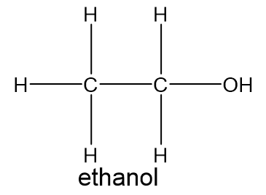
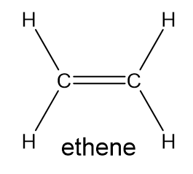

Cr₂O₇²⁻ _{(aq)} / H⁺ _{(aq)}

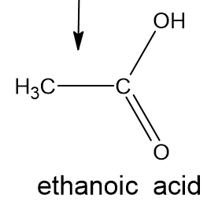
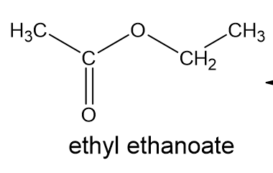

Write out the reactions in equation form, making sure to show any reactants or products not mentioned in this synthesis diagram. (you may use molecular, full or condensed formula at your preference)

A

B

C

Space for working:

Question 10 (4 marks)

Name the reaction and describe, with the use of an appropriate equation, how the salt of a 16 carbon long saturated fatty acid salt can be prepared from a triacylglyceride (triglyceride).

END OF SECTION TWO

SECTION THREE: EXTENDED RESPONSE QUESTIONS (15 marks)
Question 11 (15 marks)
Kevlar, a remarkable polymer, can be fashioned into various forms such as fibres, sheets, and rods. Kevlar's broad-ranging applications stem from its exceptional mechanical strength, light weight, high heat resistance, and remarkable chemical stability. It is most renowned for its use in bulletproof vests, owing to its extraordinary ability to absorb and distribute energy.
A segment of kevlar is shown in the diagram below.
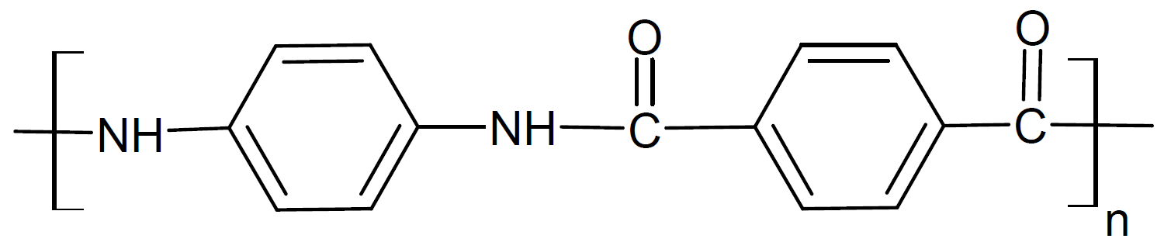
(a) Explain why Kevlar has such high tensile strength in terms of its intermolecular forces.
(2 marks)
________________________________________________________________________
________________________________________________________________________
________________________________________________________________________
________________________________________________________________________
(b) Draw the two (2) monomers from which kevlar is composed. (2 marks)
(c) Name and briefly describe the process by which these monomers are able to form this kevlar polymer. (2 marks)
________________________________________________________________________
________________________________________________________________________
________________________________________________________________________
________________________________________________________________________
A pure sample of an amine (containing only the elements carbon, hydrogen and nitrogen) was analysed to determine its composition. The amine was combusted in oxygen and produced 6.60 g of carbon dioxide, 1.80 g of water and 0.70 g of nitrogen gas.
(d) Calculate the empirical formula of the amine. (7 marks)
________________________________________________________________________
________________________________________________________________________
________________________________________________________________________
________________________________________________________________________
________________________________________________________________________
________________________________________________________________________
________________________________________________________________________
________________________________________________________________________
________________________________________________________________________
________________________________________________________________________
________________________________________________________________________
________________________________________________________________________
________________________________________________________________________
________________________________________________________________________
________________________________________________________________________
________________________________________________________________________

(e) Does this analysis provide any evidence that supports this amine might be the one used to make kevlar? Explain. (2 marks)
________________________________________________________________________
________________________________________________________________________
________________________________________________________________________
________________________________________________________________________
END OF TEST

